36.72: a) 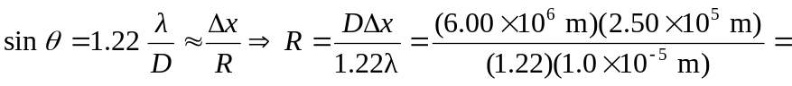
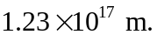
b) 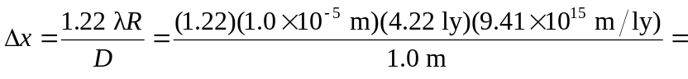
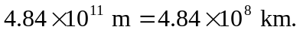
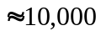 times the diameter of the earth! Not enough resolution to see an earth-like planet!
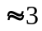 times the distance from the earth to the sun.
c)
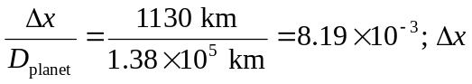 is small compared to the size of the planet.

